THE IRON BANK OF BRAAVOS

Project Report
Executive Summary
This analysis integrates customer, account, and transaction data to provide a holistic view of the bank’s profitability, risk exposure, branch performance, and fraud anomalies.
The key findings were:
- Profitability Concentration: Top 10% of our customers drive almost 82% of our net amounts.
- Risk Exposure: These branches (BR022, BR014, BR009, BR024 and BR030) have a high-risk exposure.
- Customer Health: Out of the total 500 customers, 180 hold negative balance accounts; 240 being inactive customers i.e. No transactions made in the last 3 months.
- Retention Challenges: Churn rate estimated at 48%, with retained customers showing 4× higher CLV proxy.
- Fraud Risk: No risky customers were identified.
- Much of the cash flow sits in the Current accounts.
- Retained customers are worth ~23% more than churned ones, validating the ROI of retention efforts.

Data Sources
- Customers (500 records): Demographics, region, risk segment, KYC status.
- Accounts (500 records): Account type, balance, branch, status.
- Transactions (500 records): Transaction type, amount, channel, merchant, status.

Methodology
SQL
- Most profitable customers by region/segment
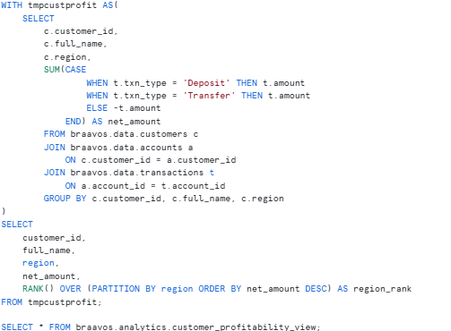
The ranks can be found in the view cust_profitability_view

- Consistently low or negative balances
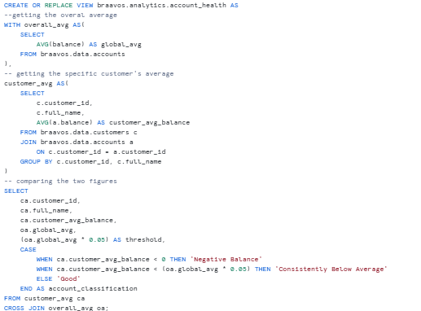

- Quiet customers (no activity in the past 3 months and more)
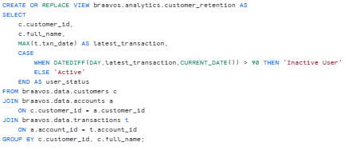
- Account types holding the most value
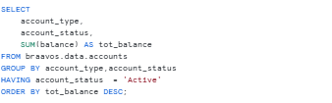
- Branches with a lot of risky customers
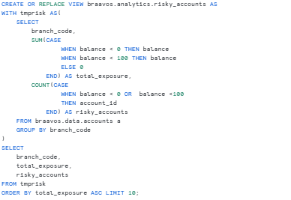
- Average and median value per account type
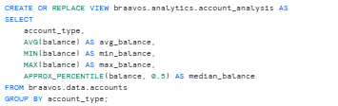

- High-risk customers with anomalies
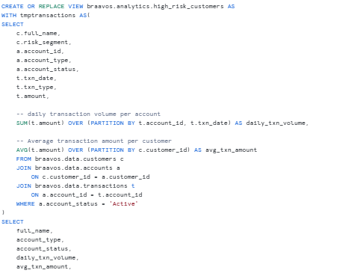
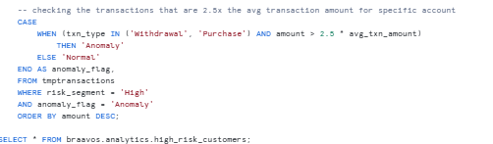
- The percentage of the total net amount driven by our top 10% of customers
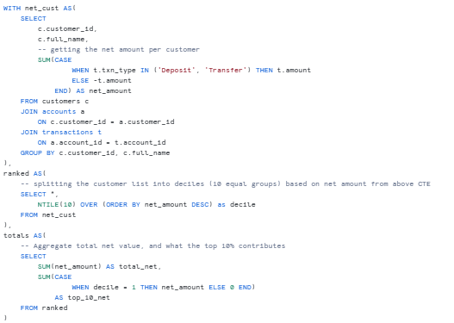
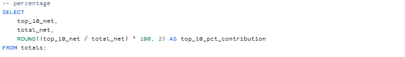

- Branch risk vs the network’s average
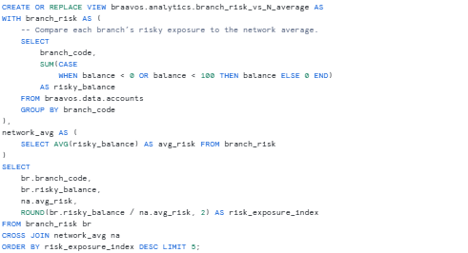
- Estimate CLV for retained vs churned customers.
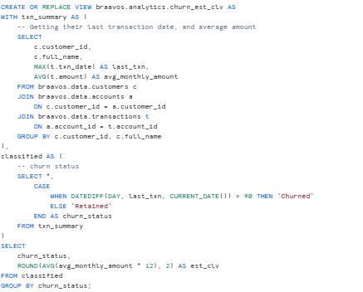

Microsoft Power BI Views
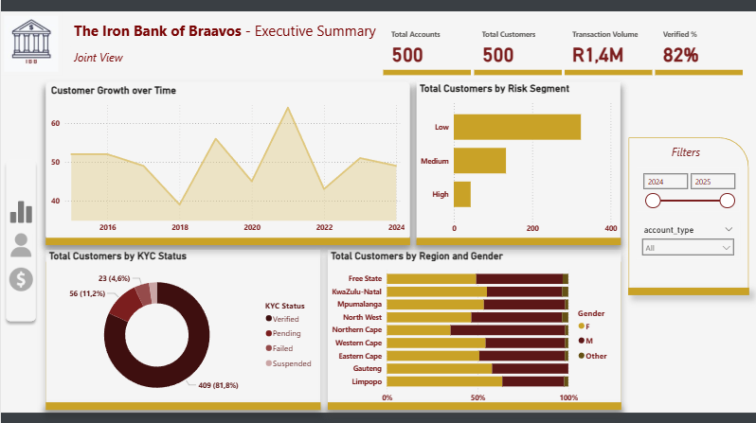
Executive Dashboard
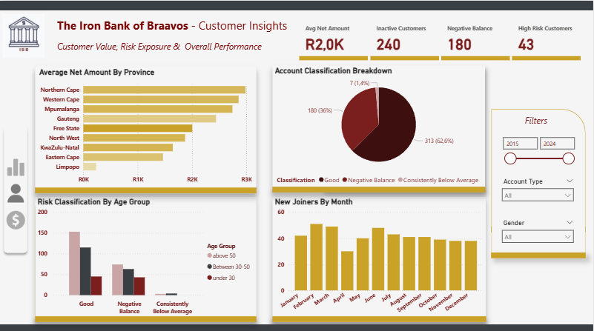
Customer Insights

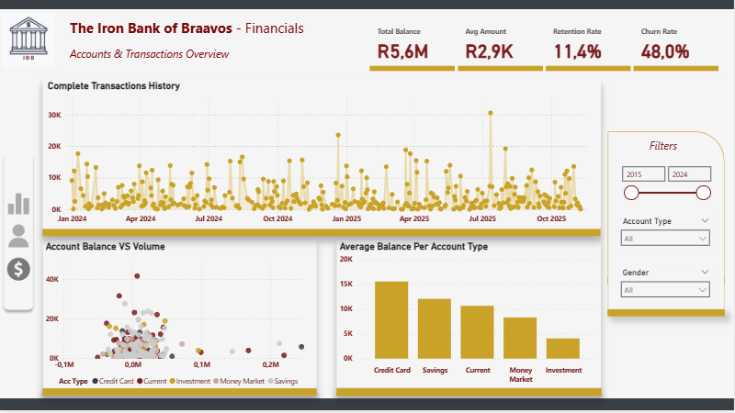Accounts & transaction analysis
Finance Math Proxies: CLV estimates, risk exposure indices, Pareto contribution analysis.
DAX Measures: KPIs for total customers, active accounts, risky accounts %, transaction volume YTD.

Analysis & Insights
Customer Profitability
- Northern Cape customers show the highest average net amounts.
- Top decile drives majority of balances, showing a strong Pareto effect.
Account Health
Account Type | Average Balance | Minimum Balance | Maximum Balance | 25th Percentile | Median | 75th Percentile
Investment | 7035.14 | -41030.8 | 120000.0 | -12355.7 | 3863.5 | 23029.7
Credit Card | 14140.85 | -50650.7 | 245145.8 | -2730.88 | 7082.85 | 21614.55
Savings | 12083.79 | -45128.8 | 247573.1 | -5456.8 | 7380.2 | 21887.1
Current | 10640.57 | -50861.7 | 219868.9 | -7319.18 | 7156.3 | 21159.65
Money Market | 8293.45 | -43270.1 | 91437.5 | -8084.13 | 4591.6 | 20381.3

Credit Card Accounts Drive Value, and risk
- Highest average balance (R14.1K) and widest range (–R50K to R245K).
- Indicates strong usage but also potential overexposure.
- Recommendation: Tighten credit limits or monitor high-balance accounts for risk.

Savings Accounts Show Stable Mid-Tier Performance
- Median (R7.3K) and average (R12K) are tightly aligned.
- Highest max balance (R247K) suggests long-term deposit behaviour.
- Recommendation: Promote savings products for retention and upsell.
Current Accounts are Volatile
- Lowest median-to-max ratio, with extreme negative balances.
- Suggests transactional use with overdraft risk.
- Recommendation: Introduce overdraft caps or dynamic risk scoring.
Investment Accounts Are Underperforming
- Lowest median balance (R3.8K) and average (R7K).
- Despite high max (R120K), most accounts are low-value.
- Recommendation: Repackage investment products or target high-net-worth segments.
Money Market Accounts Are Conservative
- Median: R4.5K, 75th percentile: R12.8K: modest, stable balances.
- Narrow range suggests low volatility.
- Recommendation: Position as low-risk, short-term holding accounts.
Branch & Product Performance
- BR026, BR019, and BR023 have a combined customer count of 29.
- Savings and Credit Card accounts dominate balances.
- Branch × Product heatmap highlights concentration in Gauteng and Western Cape.
Churn Analysis & CLV Proxy – Strategic Insight
- Retained customers are worth ~23% more than churned ones, validating the ROI of retention efforts.
- A retained customer yields ~R7,400 more in projected value, with retained customers estimated to be worth ~R39k, compared to the churned worth ~R32K.
- 240 customers are inactive (> 90 days), representing a significant revenue gap.

Recommendations
- Launch reactivation campaigns targeting inactive users, especially those with historically high balances or verified KYC status.
- Develop loyalty programs and personalized outreach for top decile customers driving 82% of net value.
- Implement stricter credit controls and enhanced monitoring protocols at these branches to mitigate downside risk.
- Tighten credit limits and monitor outliers in Credit Card accounts.
- Promote Savings accounts as stable, long-term deposit vehicles.
- Repackage Investment accounts to better serve high-net-worth segments.
- Use transaction recency, balance trends, and CLV proxy to build churn prediction models and trigger retention workflows.

